


PRIVACY NOTICES FOR WEST LANCASHIRE HAF

West Lancashire Sport Partnership
And
Shares Lancashire
March 2023
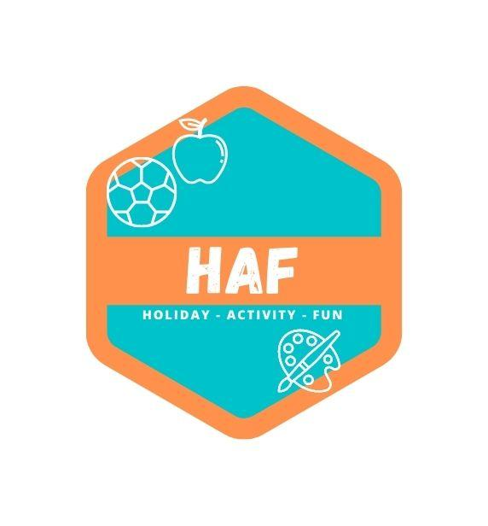

PRIVACY NOTICES FOR
WEST LANCASHIRE HAF
1. INTRODUCTION
West Lancashire HAF is multi-activity camp set up and run by West Lancashire Sport Partnership and SHARES Lancashire during the Easter holidays of 2023. The camps are open to all eligible primary and secondary school children aged between 5 and 16. For the purposes of this document ‘we’ means West Lancashire Sport Partnership and SHARES Lancashire.
This privacy notice sets out the basis on which any personal data we collect from you or your child, or that you provide to us, is handled by us. In this notice, you will see different names or terms used that you may not be familiar with, such as:
Data Controller: This person (or group of people, like a school) is in charge of the information we collect.
Data Processor: This person processes information for the data controller.
Data Protection Officer (DPO): This person makes sure we do everything the law says.
Personal Data: This means any information that can be used to identify someone such as your address and date of birth.
The categories of student information and data that we collect, hold and share include:
• Personal information (such as name, address and date of birth)
• Attendance information, such as sessions attended.
• Medical conditions including any special conditions your child may have that we need to
know about to keep them safe.
• Photographs (using photographs of your child counts as processing personal data). `
Before we take or use any photographs, we will ask you and a parent to give permission
for us to take and use pictures of you. We might use the pictures on display boards, on
social media or on the West Lancs HAF websites, for example.
2. WHY WE COLLECT AND USE THIS INFORMATION
We use yours and your children’s data:
• to provide appropriate care whilst your child is at the camp
• to comply with the law regarding data sharing
• to safeguard children
• for marketing, website and social media purposes
• for photographic displays

PRIVACY NOTICES FOR
WEST LANCASHIRE HAF

• to manage student’s medicines on school premises
• to manage the CCTV process

3. THE LAWFUL BASIS ON WHICH WE USE THIS INFORMATION
On the 25th May 2018 the Data Protection Act 1998 was replaced by the General Data Protection Regulation (GDPR). The condition for processing under the GDPR will be:
Article 6
1. Processing shall be lawful only if and to the extent that at least one of the following applies:
(c) Processing is necessary for compliance with a legal obligation to which the controller is subject;
Article 9
1. Processing of personal data revealing racial or ethnic origin, political opinions, religious or philosophical beliefs, or trade union membership, and the processing of genetic data, biometric data for the purpose of uniquely identifying a natural person, data concerning health or data concerning a natural person’s sex life or sexual orientation shall be prohibited.
2. Paragraph 1 shall not apply if one of the following applies:
(j) Processing is necessary for archiving purposes in the public interest, scientific or historical research purposes or statistical purposes in accordance with Article 89(1) based on Union or Member State law which shall be proportionate to the aim pursued, respect the essence of the right to data protection and provide for suitable and specific measures to safeguard the fundamental rights and the interests of the data subject.
The Education (Information about Individual Pupils) (England) Regulations 2013 - Regulation 5 'Provision of information by non-maintained special schools and Academies to the Secretary of State' states 'Within fourteen days of receiving a request from the Secretary of State, the proprietor of a non-maintained special school or an Academy (shall provide to the Secretary of State such of the information referred to in Schedule 1 and (where the request stipulates) in respect of such categories of pupils, or former pupils, as is so requested.'
The Education Act 1996 - Section 537A – states that we provide individual pupil information as the relevant body such as the Department for Education. Children's Act 1989 – Section 83 – places a duty on the Secretary of State or others to conduct research.
4. COLLECTING INFORMATION
Whilst the majority of information you provide to us is mandatory for your child to attend West Lancashire HAF, some of it is provided to us on a voluntary basis. In order to comply with the General Data Protection Regulation, we will inform you whether you are required to provide certain information to us or if you have a choice in this. We will use the information you give to us for the following reasons:

PRIVACY NOTICES FOR
WEST LANCASHIRE HAF

- to register and provide daytime activities for your child:
- to store this information on school network and internal filing systems;
- to protect the welfare of your child and to promote the objects and interest of our Camps; to manage any queries or disputes you or your child may have with us or that we have with you or your child;
- to enforce our terms of use with you;
- to send out surveys to you by email in order for you to provide feedback to us on our camps;
- to send out information to you by email regarding current and future camps;
- keep a list of your child’s allergies or medical requirements in case of emergency. It is
necessary for the camp to have a list readily available to our staff so that we are able to
look after your child promptly in the event of a medical emergency.
We may take photographs/videos/webcam images of children whilst on school site or away from the school site. To comply with the General Data Protection Regulation, photo consent is obtained by completion of the appropriate section of the booking form.
5. STORING DATA
Data will be retained in accordance with the ELT GDPR Compliant Records Management Policy.
6. WHO WE SHARE DATA WITH
We may share your information with the following 3rd parties,
• Travel companies for the purposes of booking, organising and managing visits and trips
arranged whilst attending the camp
• Our sites have CCTV systems to address the safety of children, staff welfare, site security
and to make evidence available to authorised investigatory bodies. The Academy’s CCTV
Policy defines the roles and responsibilities, provides staff with clear guidance about their
role whilst using the system anddescribes how data is stored & shared.
7. WHY WE SHARE INFORMATION
We do not share information about your children with anyone without consent unless the law and our policies allow us to do so.
8. DATA COLLECTION REQUIREMENTS
To find out more about the data collection requirements placed on us by the Department for Education (for example; via the school census) go to https://www.gov.uk/education/data- collection-and-censuses-for-schools.

PRIVACY NOTICES FOR
WEST LANCASHIRE HAF

9. REQUESTING ACCESS TO YOUR PERSONAL DATA
Under data protection legislation, parents and children have the right to request access to information about them that we hold. To make a request for your personal information, or be given access to your child’s record, contact the DPO.
You also have the right to:
- object to processing of personal data that is likely to cause, or is causing, damage
or distress
- prevent processing for the purpose of direct marketing
- object to decisions being taken by automated means
- in certain circumstances, have inaccurate personal data rectified, blocked, erased
or destroyed; and
- claim compensation for damages caused by a breach of the Data Protection
regulations
If you have a concern about the way we are collecting or using your personal data, please raise your concern with the DPO. If your concerns are not dealt with to your satisfaction you can contact the Information Commissioner’s Office at https://ico.org.uk/concerns/
10. FOUR IMPORTANT THINGS TO UNDERSTAND AND WHO TO CONTACT
Now you’ve read this, we hope you understand that:
- The law allows us to get and use your information to help us do our job.
- We may share your information with others, but only when we really need to.
- We will ask for your permission to share your information whenever you have a
choice.
- You can tell us not to share your information, even when you have said yes before.
If you would like to discuss anything in this Privacy Notice, please contact West Lancashire Sport Partnership at 01704 377 982.

PRIVACY NOTICES FOR
WEST LANCASHIRE HAF
11. PRIVACY NOTICE REVIEW
This Privacy Notice policy is reviewed by the Executive Headteacher and Local Academy Council.

Review Date | Changes Made
May 2018 | First Issue
February 2019 | Change of title to Endeavour Holiday Camps and to add Burscough Priory Academy
June 2021 | Adapted for West Lancashire HAF Summer 2021

Signed by:
Mr M Forster | Director of  West  Lancashire  Sport  Partnership | Date | 15/06/2021
Mr K Davidson | Chief Executive of SHARES  Lancashire | Date | 15/06/2021

